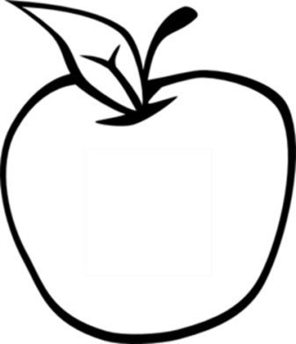

News from room 217

kory217.weebly.com

Ms. Kory

3rd Grade

Disney Magnet School

Here’s what we’ll be working on this week:

* **Reading –** This week we’ll be reading What Do Illustrators Do? and discussing the purpose of different features of nonfiction like captions and headings.

* **Writing** – With the personal narratives published, students will begin working on opinion writing.

* **Social Science** – This week will start learning about communities as places and working on map skills.
* **Math** – The first part of the week we will review for the unit assessment of the four chapters we’ve studied so far. The end of the week we will begin a new chapter on multiplication.
* **Science** – Students will investigate renewable and nonrenewable resources and learn about recycling.

#### Dates to remember

October 21st

picture day

October 25th

movie night

October 30th

film festival

November 1st

no school

#### Vocabulary Words:

imagine

tools

illustrations

scribble

sketch

tracing

research

texture

## Week 9

October 21st, 2013