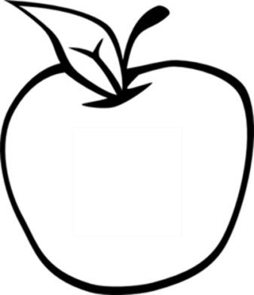

News from room 217

kory217.weebly.com

Ms. Kory

3rd Grade

Disney Magnet School

Don’t forget you can find these newsletters, the thinkcentral guide, and student homework assignments on my website.

Here’s what we’ll be working on this week:

* **Reading** – This week we will use a Venn diagram to compare and contrast the characters in Pop’s Bridge.
* **Writing** – Students will work on adding details to a personal narrative.
* **Social Science**—Students will work on creating a class book that shows different parts of our community.
* **Math** – We start chapter three this week, which focuses on adding three-digit numbers.
* **Science**—We are finishing our rocks and minerals unit this week. The test will be on Wednesday.

#### Dates to remember

September 25th

Progress reports

October 14th

No school

#### Vocabulary Words:

foggy

disappears

stretch

excitement

crew

tide

cling

balancing

## Week 5

September 23rd, 2013