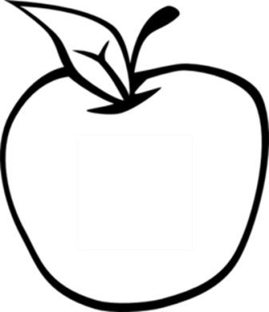

News from room 217

Ms. Kory

3rd Grade

Disney Magnet School

Here’s what we’ll be working on this week:

* **Reading** – This week we will be drawing conclusions based on text clues.
* **Writing**—Students will work on adding dialogue to their writing.
* **Social Science**—We will continue to discuss what makes a community.
* **Math –** Students took their first test today. Tomorrow, we will start ordering numbers by comparing place value.
* **Science** – Students will study the three types of rocks more closely and start to investigate fossils.

Hope to see you at the Parent Open House on Thursday!

#### Dates to remember

September 12th

Parent Open House

6:00-7:00

September 25th

Progress reports

October 14th

No school

#### Reminders:

 Don’t forget you can check the class website for homework and other information.

Kory217.weebly.com

## Week 3

September 9th, 2013