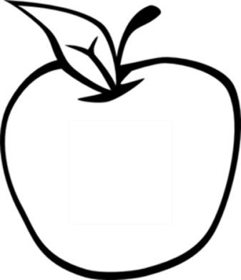

News from room 217

kory217.weebly.com

Ms. Kory

3rd Grade

Disney Magnet School

Here’s what we’ll be working on this week:

* **Reading** – We will be reading A Tree is Growing and discussing nonfiction text features that the author includes.
* **Writing** – Students will write a problem and solution paragraph including the problem, possible solution, supporting details, and a closing sentence.
* **Social Science** – Students will be reading about ecosystems in social studies as well, and how humans affect the environment.
* **Math** – Our decimals test will be on Thursday, a review sheet will go home as always on Wednesday.

* **Science** – Students will learn about grasslands and water ecosystems.

#### Dates to remember

March 27th

end of 3rd quarter

April 3rd

field trip to the Museum of Science and Industry

April 7th

report card pick-up

#### Vocabulary Words:

pollen

store

clumps

passages

absorb

throughout

coverings

spines

tropical

dissolves

## Week 29

March 24th, 2014