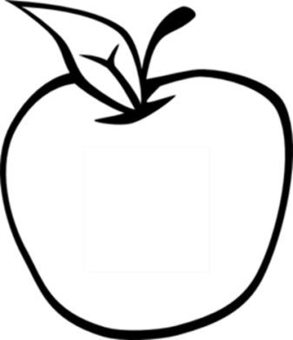

News from room 217

kory217.weebly.com

Ms. Kory

3rd Grade

Disney Magnet School

Here’s what we’ll be working on this week:

* **Reading** – We’ll be reading The Albertosaurus Mystery and discussing how scientists and readers use clues to make inferences.
* **Writing –** Students will practice writing an opinion paragraph using a good closing sentence.
* **Social Science** – We begin a new chapter, looking more closely at maps and geography.
* **Math**—This week we introduce decimals and the relationship between fractions, tenths, and hundredths.
* **Science** – Students will study forest ecosystems and desert ecosystems.

#### Dates to remember

March 27th

end of 3rd quarter

April 3rd

field trip to the Museum of Science and Industry

April 7th

report card pick-up

#### Vocabulary Words:

fossils

clues

remains

prove

evidence

skeletons

uncovering

buried

fierce

location

## Week 28

March 17th, 2014