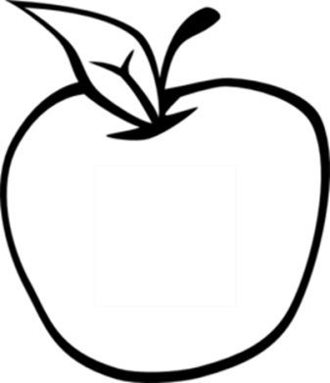

News from room 217

kory217.weebly.com

Ms. Kory

3rd Grade

Disney Magnet School

Here’s what we’ll be working on this week:

* **Reading** – We will read a biography of Thomas Edison and practice finding the main idea and supporting details in a nonfiction text.
* **Writing**—Students will complete their response to literature paragraphs.
* **Social Science** – Students will learn about the branches and levels of government.
* **Math** – We will take our test on chapter 9 on Wednesday. Please use the fact triangles to practice with your student at home!
* **Science** – This week we will finish talking about the ways that forces can change the land. Our test will be on Monday of next week.

#### Dates to remember

December 11th

progress reports

December 18th

winter concert

December 23rd – January 3rd

Winter Break

#### Vocabulary Words:

invention

experiment

laboratory

genius

gadget

electric

signal

occasional

## Week 15

December 2nd, 2013