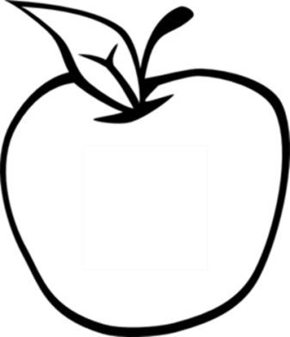

News from room 217

kory217.weebly.com

Ms. Kory

3rd Grade

Disney Magnet School

I’m looking forward to meeting with all of you next Tuesday at report card pick-up to discuss the excellent progress your students have been making so far this year. Here’s what we’ll be working on this week:

* **Reading** – We will extend our work with the story The Harvest Birds by performing Readers’ Theater. The vocabulary words and spelling words will be the same as last week.
* **Writing** – Students will publish their opinion writing pieces by editing and creating a final version.
* **Social Science** – We will study the history of a community and students will make a timeline of their own history.
* **Math** – The chapter 7 math test will be on Wednesday, covering multiplication strategies and vocabulary.
* **Science** –Students reviewed today for the science test on Wednesday about natural resources. Additional review work will go home Tuesday night.

#### Dates to remember

November 11th

no school

November 12th

report card pick-up

November 27th-29th

Thanksgiving

Break

#### Vocabulary Words:

harvest

separate

ashamed

borders

advice

borrow

patch

serious

## Week 11

November 4th, 2013